Unit 4 Quiz 1 Graphing Quadratics

Graph and label at least 5 points.

$$1.) y=-2(x+4)^{2}+5$$

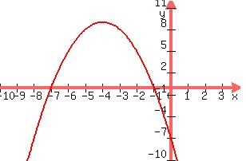

$$2.) y=x^{2}-6x+4$$

Write the Equation of the graph below.

3.)

Answer the following.

4.) A kid throws a ball up and the path it travels is modeled by the equation h = −5t2 + 14t + 3 where h is the height of the ball in feet and t is the time in seconds. Identify: the highest point the ball reaches, how long it takes to get there, and how long will it take the ball to hit the ground.